An IP address has 2 parts:
- Network ID → Identifies the network.
  - All devices in the same network have the same Network ID.
- Host ID → Identifies the specific device on that network.
  - Every device must have a unique Host ID.
Example
IP Address: 192.168.1.10/24
- Network ID: 192.168.1.0
- Host ID: 10
Here:
- 192.168.1 = Network part
- 10 = Host part
Easy way to explain to students
Think of it like an apartment building:
- Network ID = Apartment Building Address 🏢
- Host ID = Apartment Number 🚪
Example:
- Building: 192.168.1
- Apartment: 10
So 192.168.1.10 means:
- Go to Building 192.168.1 (Network ID)
- Then find Apartment 10 (Host ID)
Remember:
- Network ID tells which network.
- Host ID tells which device in that network.
- The subnet mask or CIDR (like /24) decides where the Network ID ends and the Host ID begins.

All devices connected to the same Wi-Fi network have the same Network ID, but different Host IDs.
Example:
Device | IP Address | Network ID | Host ID
Laptop | 192.168.1.10 | 192.168.1.0 | 10
Phone | 192.168.1.20 | 192.168.1.0 | 20
TV | 192.168.1.30 | 192.168.1.0 | 30
- Network ID → Same for everyone (192.168.1.0)
- Host ID → Different for every device (10, 20, 30)
One-line explanation for students:
Devices connected to the same Wi-Fi have the same Network ID but different Host IDs so each device can be uniquely identified. ✅

How to find host Id from network id
The subnet mask (or CIDR) tells you which part is the Network ID and which part is the Host ID.
Example 1 (Most common)
IP Address: 192.168.1.10/24
- /24 means the first 24 bits are the Network ID.
- The last 8 bits are the Host ID.
So:
- Network ID: 192.168.1.0
- Host ID: 10
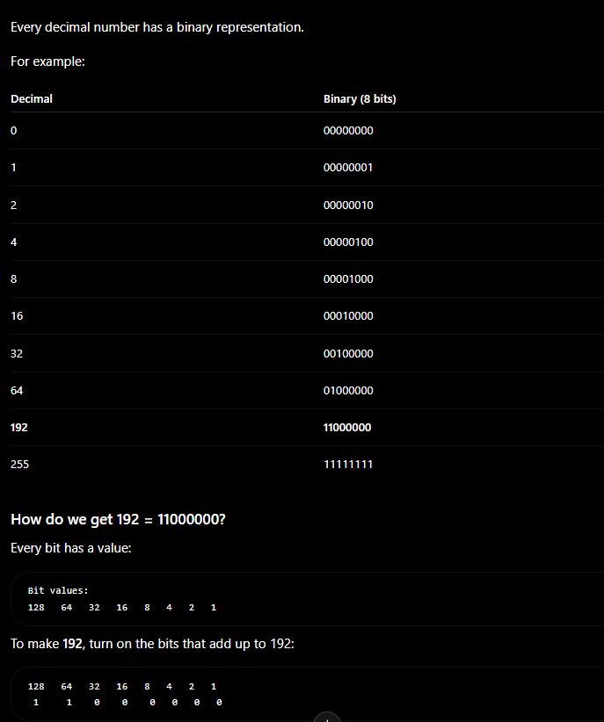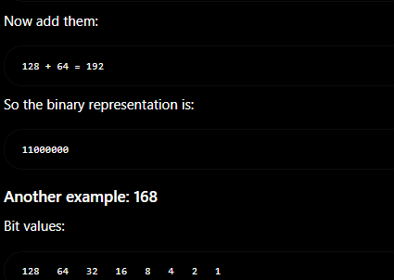
CIDR .
CIDR (Classless Inter-Domain Routing) tells us how many bits of an IP address belong to the Network ID. The remaining bits belong to the Host ID.
Examples:
- /8 → 8 bits Network, 24 bits Host
- /16 → 16 bits Network, 16 bits Host
- /24 → 24 bits Network, 8 bits Host
For example:
IP: 192.168.1.10/24
- Network bits: First 24 bits (192.168.1)
- Host bits: Last 8 bits (10)
CIDR is a notation that tells us how many bits are used for the Network ID and how many bits are left for the Host ID.
That's the simplest and correct explanation. After they understand this, you can teach that /24 is the same as subnet mask 255.255.255.0.

We use 2 because every bit in binary has only 2 possible values:
- 0
- 1
IPv4 has 5 IP classes:
Class | First Octet Range | Default Subnet Mask | Purpose
Class A | 1–126 | 255.0.0.0 (/8) | Very large networks
Class B | 128–191 | 255.255.0.0 (/16) | Medium-sized networks
Class C | 192–223 | 255.255.255.0 (/24) | Small networks
Class D | 224–239 | No subnet mask | Multicast
Class E | 240–255 | No subnet mask | Experimental/Research
Easy trick to remember
- A = 1–126 → /8
- B = 128–191 → /16
- C = 192–223 → /24
- D = 224–239 → Multicast
- E = 240–255 → Experimental
Examples
- 10.0.0.1 → Class A
- 172.16.5.10 → Class B
- 192.168.1.10 → Class C
- 230.1.1.1 → Class D
- 245.10.10.10 → Class E
Note: In modern networking, we mostly use CIDR (Classless Inter-Domain Routing) instead of IP classes, but learning classes is still useful for understanding networking basics and interviews.
Good question.
Class D (224–239) = Multicast
Multicast means one sender sends data to many selected devices at the same time.
Example:
- A company is streaming a live meeting to 100 employees.
- Instead of sending 100 separate copies, it sends one multicast stream, and everyone who joins receives it.
So:
- Unicast = One → One
- Broadcast = One → Everyone
- Multicast = One → Many (only the devices that joined the group)

Class E (240–255) = Experimental
This range is reserved for research and testing.
It is not used for normal computers or networks.

What should you remember?
- Class D (224–239) → Multicast (one sender to many receivers)
- Class E (240–255) → Experimental (reserved for testing and research)
For your exam or interview, you don't need to know the internal working of multicast or experimental addresses. Just remember:
- D = Multicast
- E = Experimental

What is a Subnet Mask?
Definition:
A subnet mask is a 32-bit number that tells us which part of an IP address is the Network ID and which part is the Host ID.
Easy Rule
- 255 = Network
- 0 = Host
Example
IP: 192.168.1.10/24
Subnet Mask: 255.255.255.0
- 192.168.1 → Network ID
- 10 → Host ID
Important Note
You cannot find the subnet mask from only the IP address. You also need the CIDR.
For example:
- 192.168.1.10/24 → 255.255.255.0
- 10.0.0.1/8 → 255.0.0.0
- 172.16.5.10/16 → 255.255.0.0
One-line answer for exams
"A subnet mask is used to identify the Network ID and Host ID of an IP address."
There are two conversions you should know.
1. CIDR → Subnet Mask
Example:
- /24
- Binary:
- 11111111.11111111.11111111.00000000
- Subnet Mask:
- 255.255.255.0
So:
CIDR → Binary → Subnet Mask

2. Subnet Mask → CIDR
Example:
- 255.255.255.0
- Binary:
- 11111111.11111111.11111111.00000000
- Count the number of 1s:
  - 8 + 8 + 8 = 24
So:
Subnet Mask → Binary → Count the 1s → CIDR (/24)

Remember this table
CIDR | Subnet Mask
/8 | 255.0.0.0
/16 | 255.255.0.0
/18 | 255.255.192.0
/20 | 255.255.240.0
/24 | 255.255.255.0
So yes, there are two conversions:
- ✅ CIDR → Subnet Mask
- ✅ Subnet Mask → CIDR
That's exactly how networking engineers work with IP addresses.
Great. Let's explain it as if you're teaching a beginner.
Example: 192.168.0.0/18
Step 1: What does /18 mean?
- /18 means 18 bits are Network ID.
- Remaining 14 bits are Host ID.

Step 2: Convert CIDR to subnet mask
/18 = 255.255.192.0

Step 3: Find the block size
Interesting octet = 192
256 - 192 = 64
So the third octet increases in blocks of 64:
0
64
128
192
256 (stop)

Step 4: Create the network ranges
First network:
192.168.0.0 → 192.168.63.255
Second network:
192.168.64.0 → 192.168.127.255
Third network:
192.168.128.0 → 192.168.191.255
Fourth network:
192.168.192.0 → 192.168.255.255

What is a Network Range?
A network range is:
The first IP address and the last IP address that belong to one network.
For the first network:
192.168.0.0 → 192.168.63.255
Every IP between these belongs to the same network.
For example:
192.168.0.1
192.168.10.25
192.168.30.100
192.168.63.200
All of these are inside the same /18 network.
But this IP:
192.168.64.5
❌ is not in that network.
It belongs to the next network:
192.168.64.0 → 192.168.127.255
Broadcast Address means:
The last IP address in a network. It is used to send data to all devices in that network at the same time.
Example
Network: 192.168.0.0/24
- Network Address = 192.168.0.0
- First Host = 192.168.0.1
- Last Host = 192.168.0.254
- Broadcast Address = 192.168.0.255
Why is it called "Broadcast"?
Imagine a teacher wants to send one message to every student in a classroom.
Instead of sending the message to each student one by one, the teacher says it once so everyone hears it.

Why do we need the network range?
Imagine a company has 5,000 computers.
They create one subnet:
192.168.0.0/18
Now the administrator immediately knows:
- Every IP from 192.168.0.0 to 192.168.63.255 belongs to this subnet.
- Any IP outside this range belongs to another subnet.
This helps with:
- ✅ Organizing networks.
- ✅ Routing traffic.
- ✅ Creating AWS VPC subnets.
- ✅ Configuring routers and switches.
- ✅ Assigning IP addresses.

Easy definition for students
Network range is the starting IP address and ending IP address of a subnet. Every IP between them belongs to the same network.
For your example:
IP Address : 192.168.0.0/18

Subnet Mask : 255.255.192.0

Network Range :
192.168.0.0 → 192.168.63.255
This is the simplest and most practical explanation to teach beginners.

IMP
IPv4 = 32 bits

Host bits = 32 - CIDR

Total IPs = 2^(Host bits)

Usable Hosts = Total IPs – 2

/8
Keep 1st octet
Example:
192.168.0.0/8
Range:
192.0.0.0 → 192.255.255.255

/16
Keep first 2 octets
192.168.0.0 → 192.168.255.255

/24
Keep first 3 octets
192.168.0.0 → 192.168.0.255

